Paper Examination

Name: 崔欣宇

Email: xinyucui99@gmail.com

Phone: +8617717977604

(1) We have a NodeJS project on github: <https://github.com/letilvy/sccd-service>. To run it on our Jenkins server, we have to clone the code from the Jenkins and execute it as follow:

*Git clone* [*https://github.com/letilvy/sccd-service.git*](https://github.com/letilvy/sccd-service.git)

*node bin/main.js*

on Jenkins. This clone operation has to be carried out each time when we run the code. In order to reduce the network payload and also make the code not understandable by others, we want to ugly the code just like what [npm uglyfly-js](https://www.npmjs.com/package/uglyfly-js) do.

Please try to provide your solution about how to do this uglification which meets following requirements:

AC1: The size of current code package is about 14 MB, reduce the size as much as possible.

AC2: The content should be as fuzzy as possible to make result code incomprehensible.

AC3: The ugly operation can be executed in CLI, such as [git bash](https://gitforwindows.org/). For example,

*./Your-uglify-command <source-code-folder-name> <target-code-folder-name>*

We just need to run the above command in our CLI, then we can get the ugly code within folder “target-code-folder-name”.

AC4: The ugly code can be run in the same way as source code, which looks like:

*node main.js*

AC5: Please provide an executable solution here since we need to check its efficiency on our laptop. Something like pseudocode is NOT acceptable.

(2) We have two tables “TA” and “TB” with following same structure in our data base:

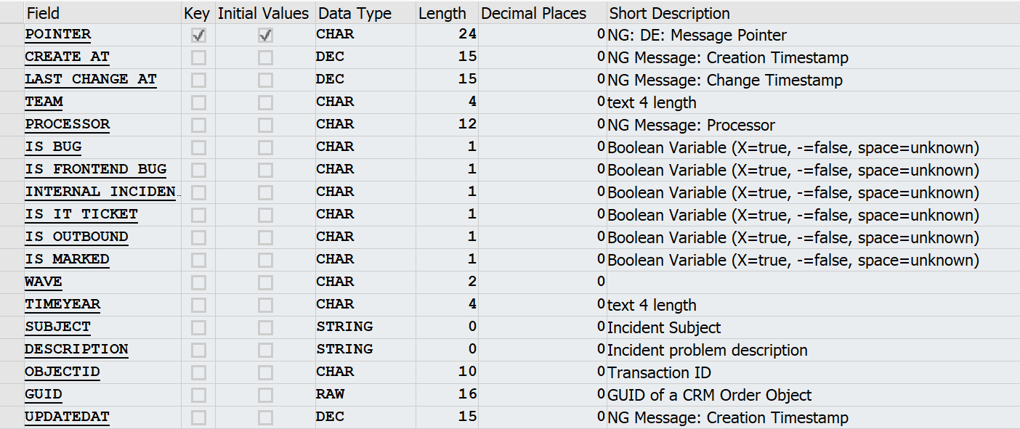

TA and TB store the same data. TA is productive table which interact with end user while TB works as backup. We have a background data synchronization mechanism “BDSM” on the system. When data in TA is updated due to user operation, BDSM will be triggered automatically to replicate this data change into TB which ensure data consistency of TA and TB.

However, BDSM does not take effect always due to unpredictable reason sometimes. Suppose we cannot change BDSM, please try to provide your solution which meets following requirements:

AC1: When data inconsistency happens on TA and TB, it must be fixed within 1 minute automatically.

AC2: You can use Java or [NodeJS](https://nodejs.org/en/) to produce your solution code, and [MySQL](https://dev.mysql.com/doc/) syntax for database relative operation.

AC3: Executable solution is preferred.

(3) The following is a web page that displays well on laptop.

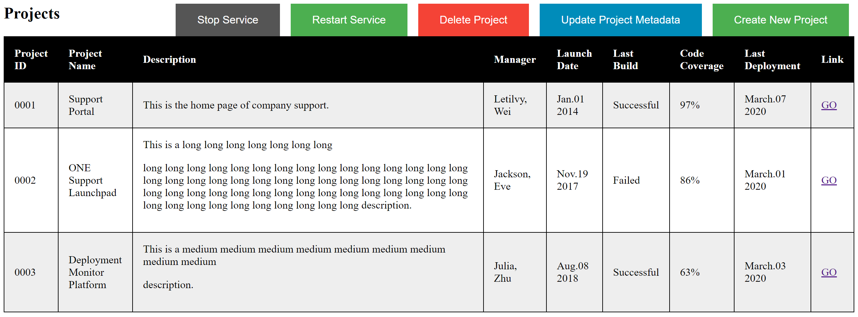

However, when you open it on phone, it looks like:

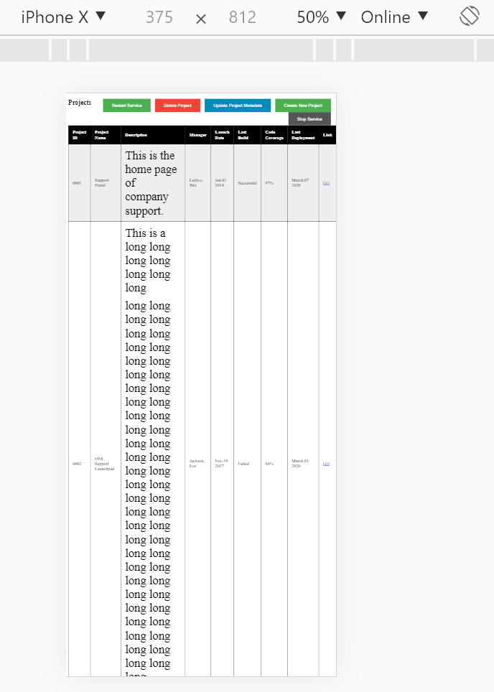

*(This is screenshot of Chrome device toolbar . We use it for device, such as iPhone X, test)*

Please try to provide your user experience improvement solution which meets following requirements:

AC1: UI layout on phone does not need to same with laptop, you can redesign the UI layout and appearance. But you have to ensure that all content still can be access on Phone.

AC2: Height of each row on phone should be similar (no need to be exactly the same).

AC3: The new UI should be responsive on both laptop and phone. For phone, you have to cover iPhone X, iPhone 6/7/8, iPhone 6/7/8 Plus, iPhone 5/SE, iPad and iPad Pro. All of these devices are available on Chrome device toolbar as follow:

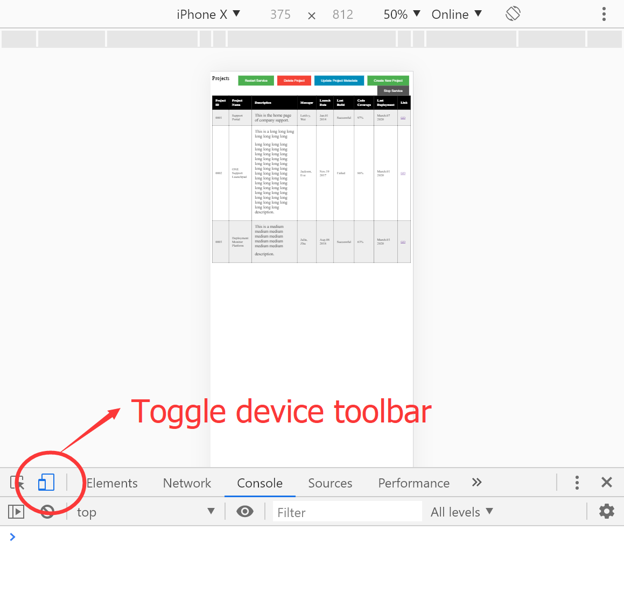

You can do the test within the above page.

AC4: Source code goes here . Please provide an executable solution here since we need to check its availability on our laptop. Something like pseudocode is NOT acceptable.